**Creating a Job and custom Execution Method inside JAMS to reference custom .dll files**

Before you can use your dll files in JAMS you need to bring the .dll and .pdb files into the MVPSI/JAMS/Client and MVPSI/JAMS/Scheduler directory. You will do this for your Host project .dlls and your custom .dlls coming from other projects that you are wanting to reference. I grabbed the dll and pdb files from by Source Control location’s bin folder and then dropped them into C:/Program Files/MVPSI/JAMS/Client and C:/Program Files/MVPSI/JAMS/Scheduler folders. You want to make sure that the JAMS Client and the JAMSScheduler Service is not running.

1. Create your execution method by clicking on “Execution Method” in the “Views” panel.

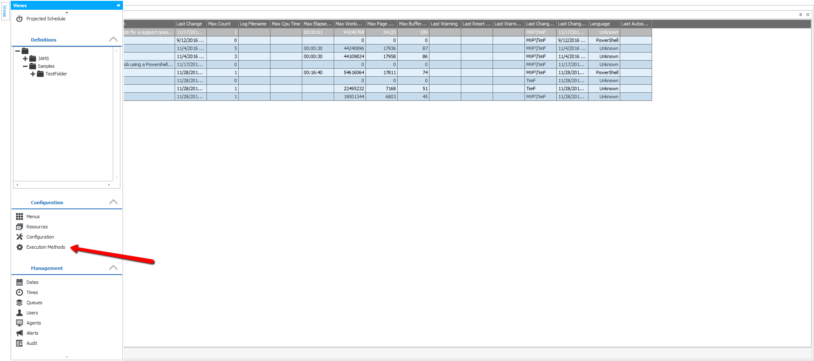

1. Click “Add” to add a new Execution Method to bring up the Wizard

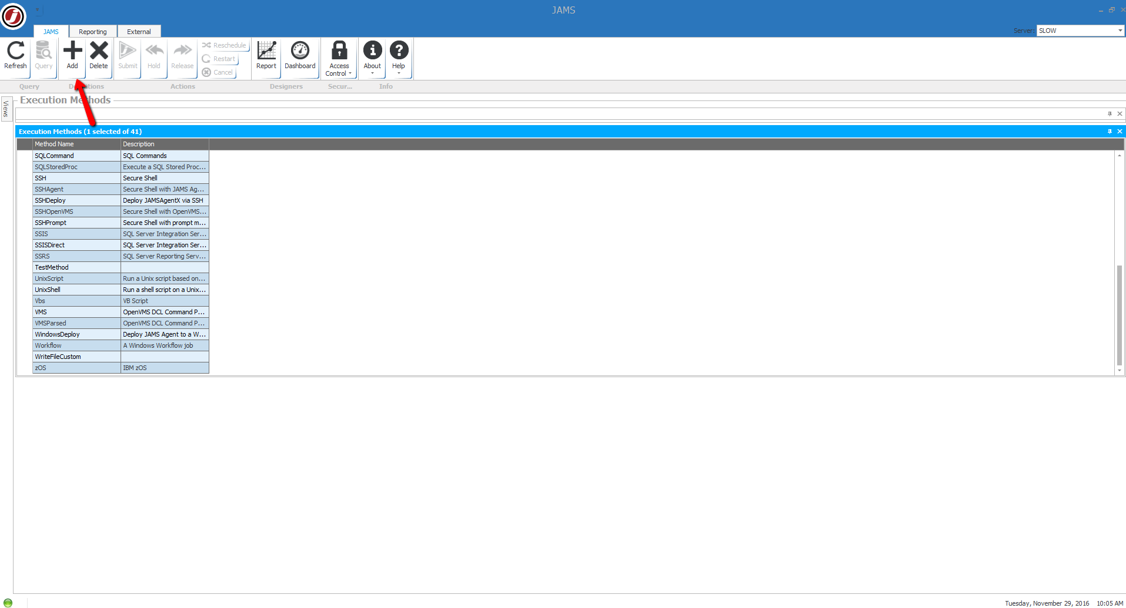

1. Name your Execution Method and click “Next”

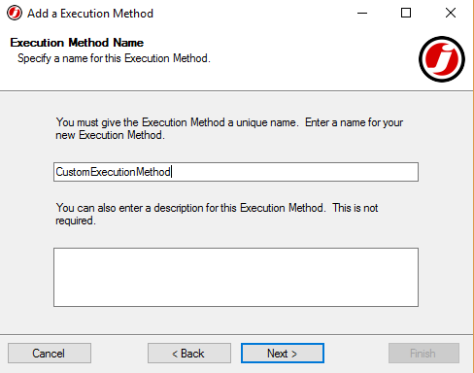

1. Select “SqlCommand” as Base Execution Method and click “Next”

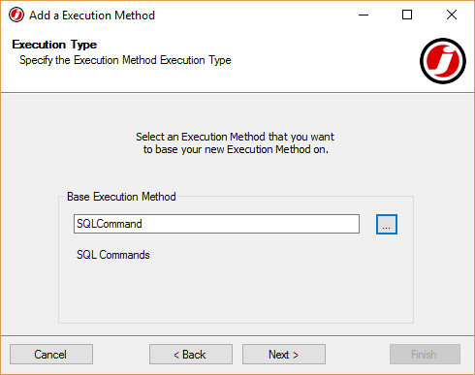

1. Select the “Edit the Execution Method definition after adding” checkbox and click “Finish”

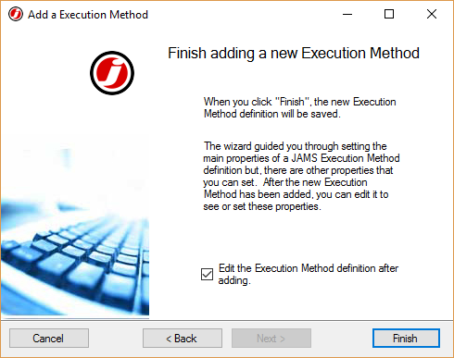

1. Inside of your Execution Method navigate to the “Execution Tab”. This is where you will bring your .dll’s into the Execution Method definition. Make sure you have “Routine” checked as Execution Method “Type”. Further down you will see “Routine Location” and “Source Editor”. This is where you will point the Method to use

In “Routine Location, you will notice “Assembly” and “Class”. The “Assembly” is going to be the name of your .dll. The class is going to be the class inside your project the .dll is coming from that you are referencing. In my example, I referenced “JAMSIntegratedDll” as the name of my .dll and JAMSIntegratedDll.WriteFileHost as the name of my class.

In “Source Editor” you will also notice “Assembly” and “Class”. The “Assembly” again is going to be the name of your .dll. The “Class” is going to be the name of your class that defines what’s on the Source tab view. So If you created a GUI like I did, I just called the class that built my GUI “WriteFileControl”.

(See next page for example)

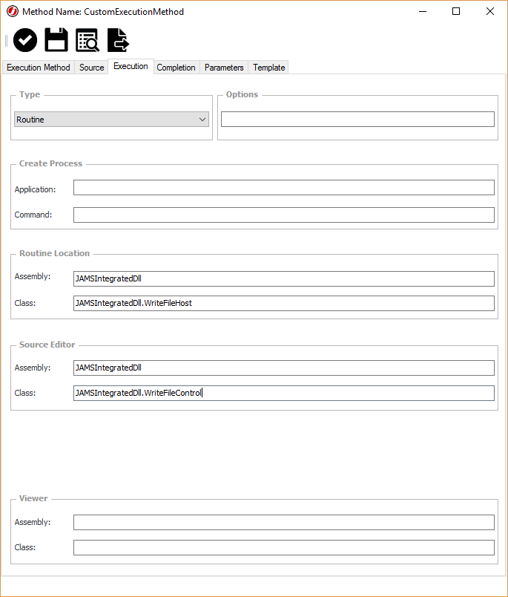

1. Next you need to create a job inside of JAMS to use that Execution Method. Inside of the “Views” Panel again, Select the folder where you want to create your Job and select “Add” to create a new one.

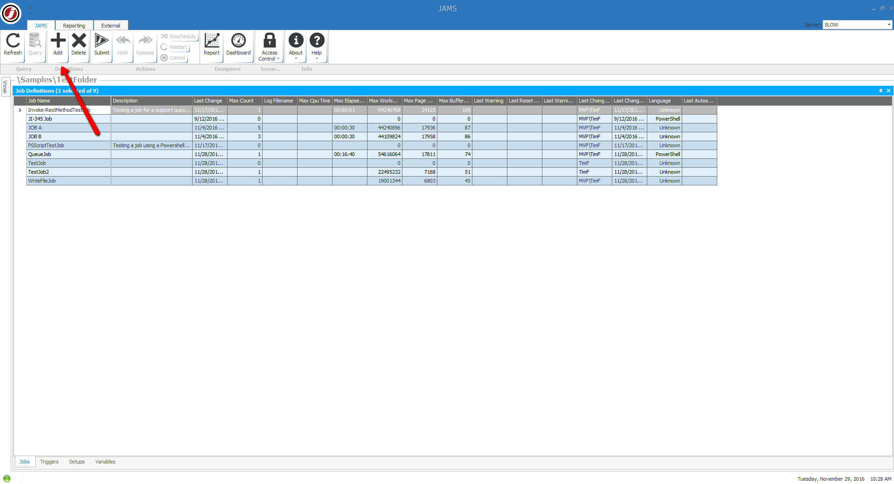

1. Again, go through the Wizard to create your Job. First give it a name.



1. When you get to the next slide it should allow you to select your “Execution Method that you just created”. Hint: You may need to hit refresh if you do not see your Execution Method appear at first.

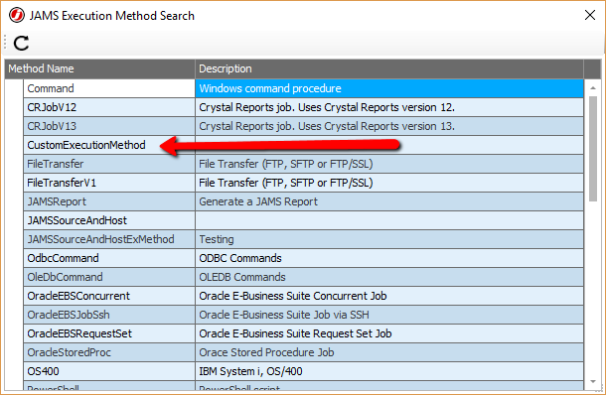

1. Continue going through the Wizard until you get to the “Source” option. At this point you should now see the Source “view” that you created and are referencing.

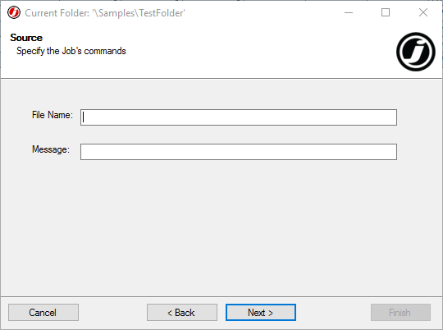

1. Again, continue through the Wizard and select the “Edit Job after creating definition” checkbox before clicking “Finish”. Once you have done this you should also, be able to see your custom Source in the “Source” tab of the Job definition.

